Monday Memory Club
11am-2pm
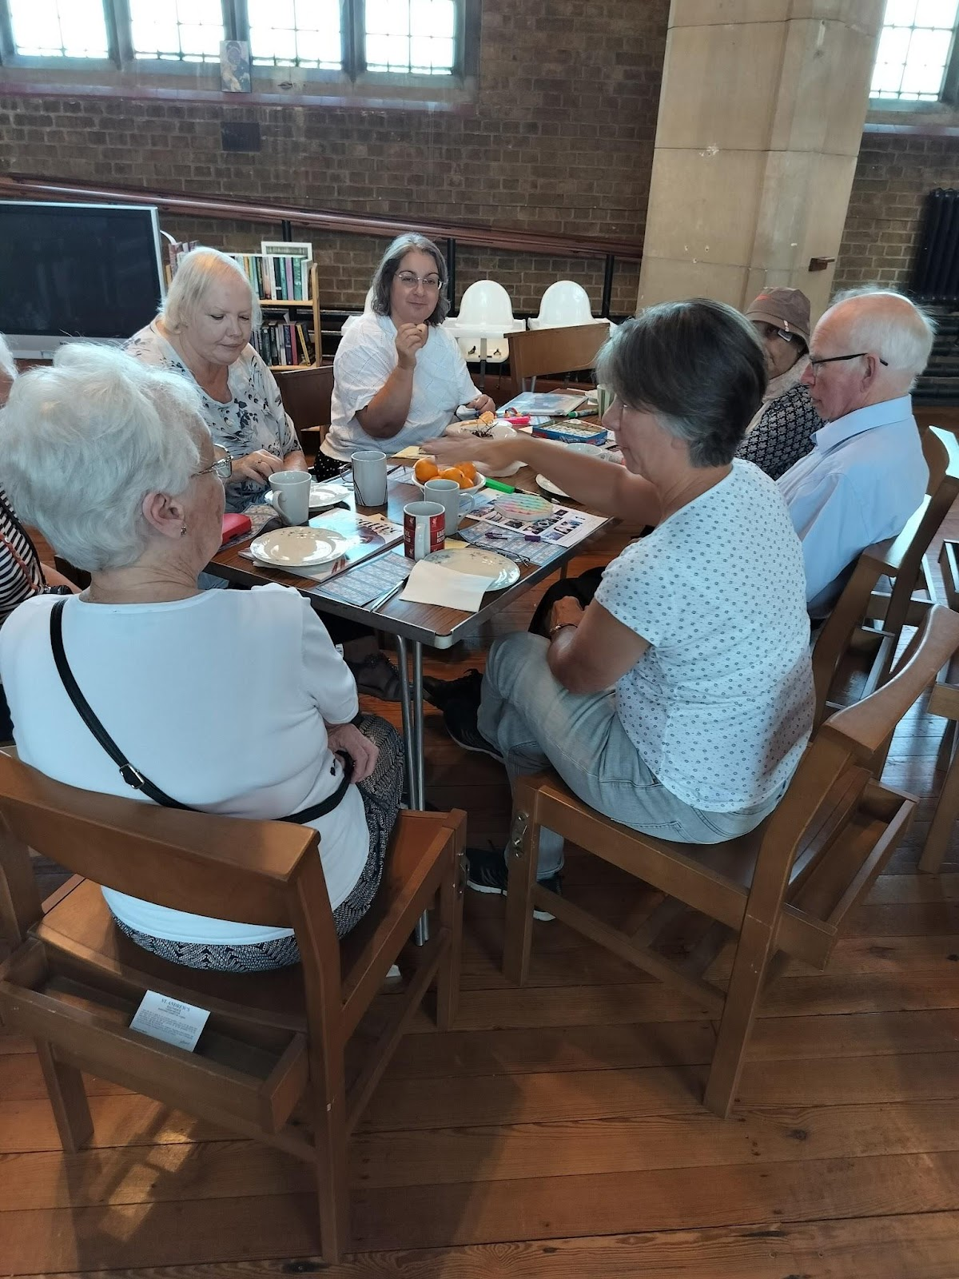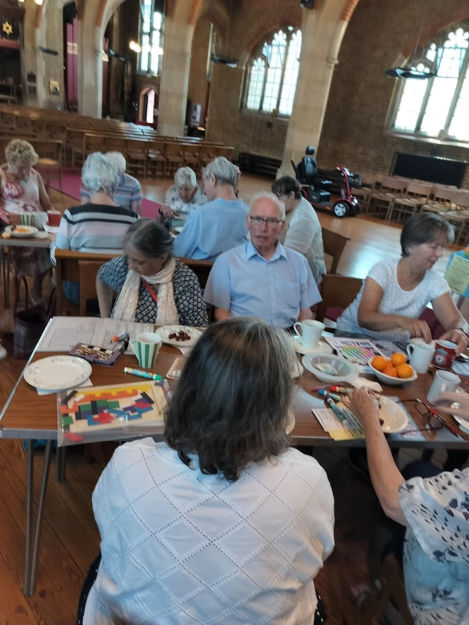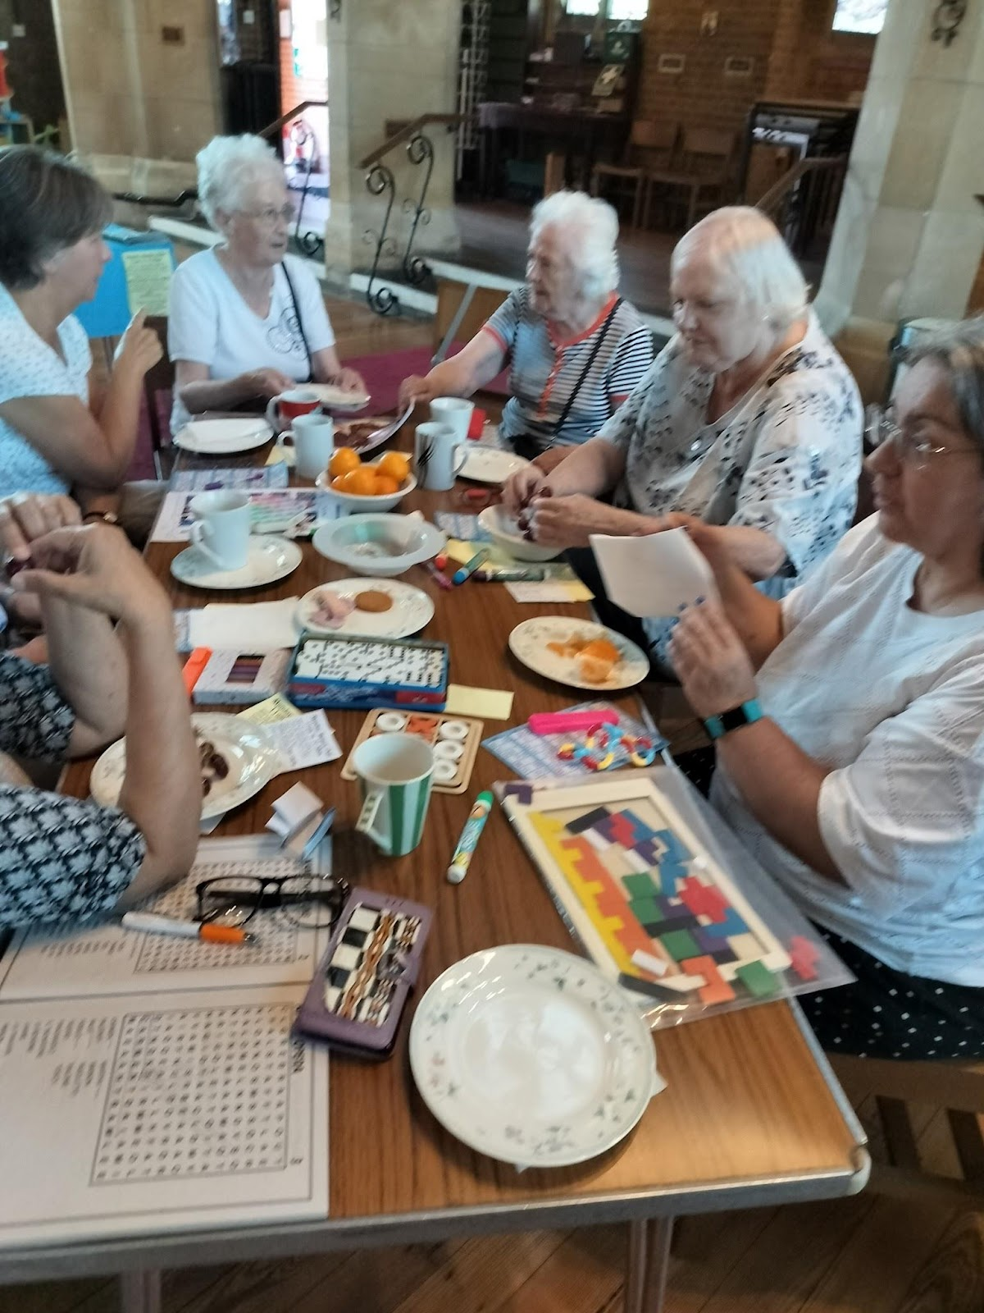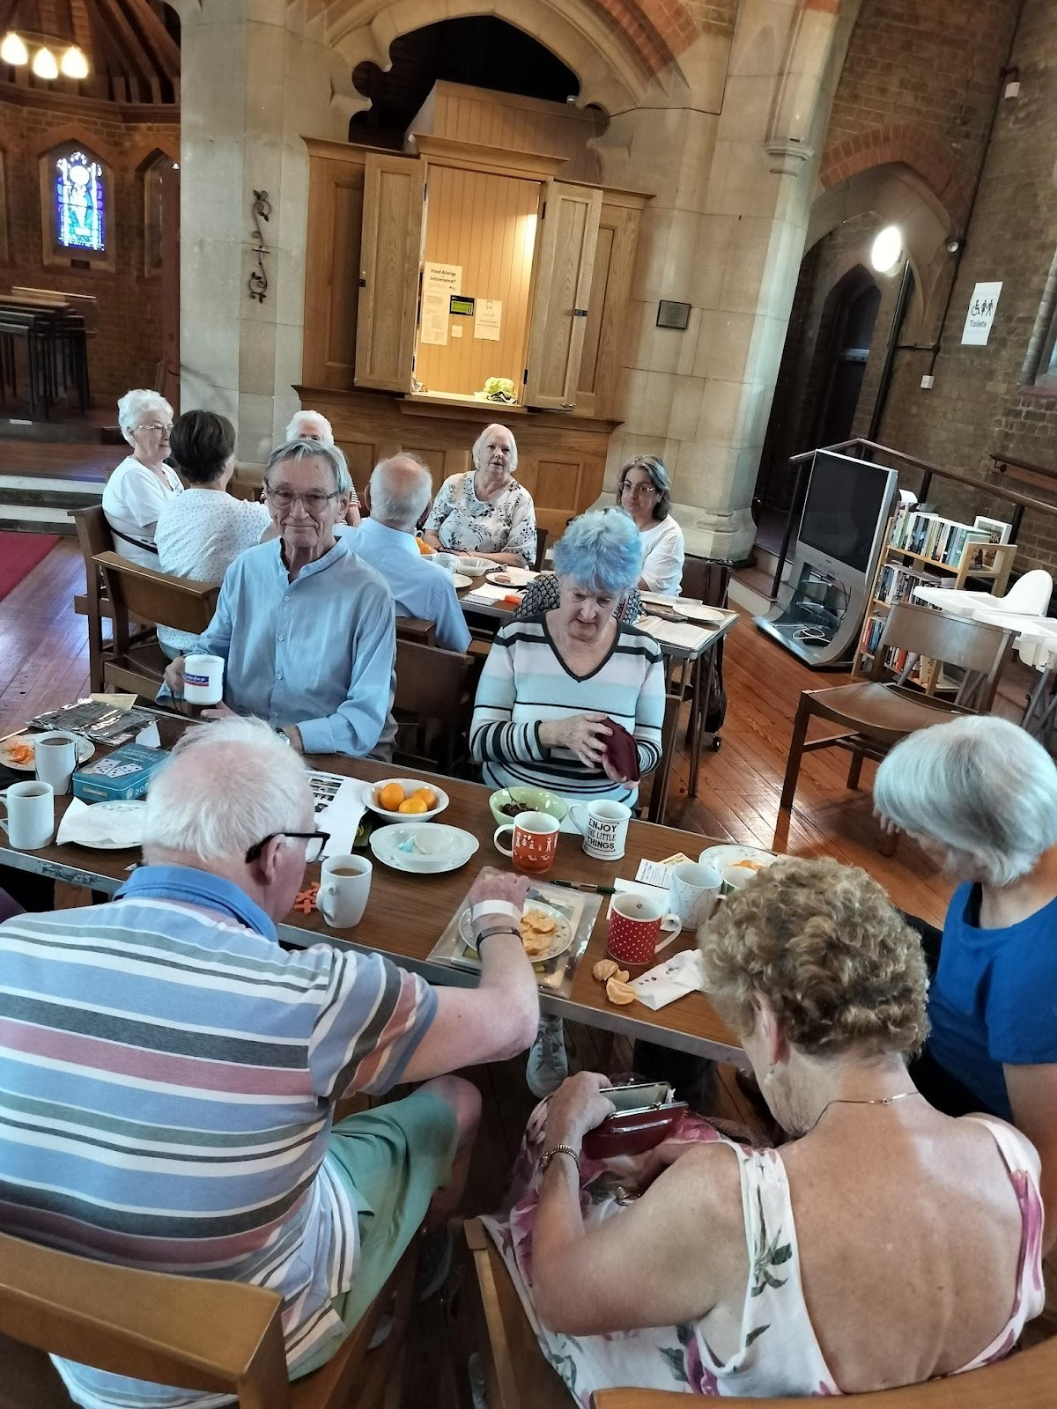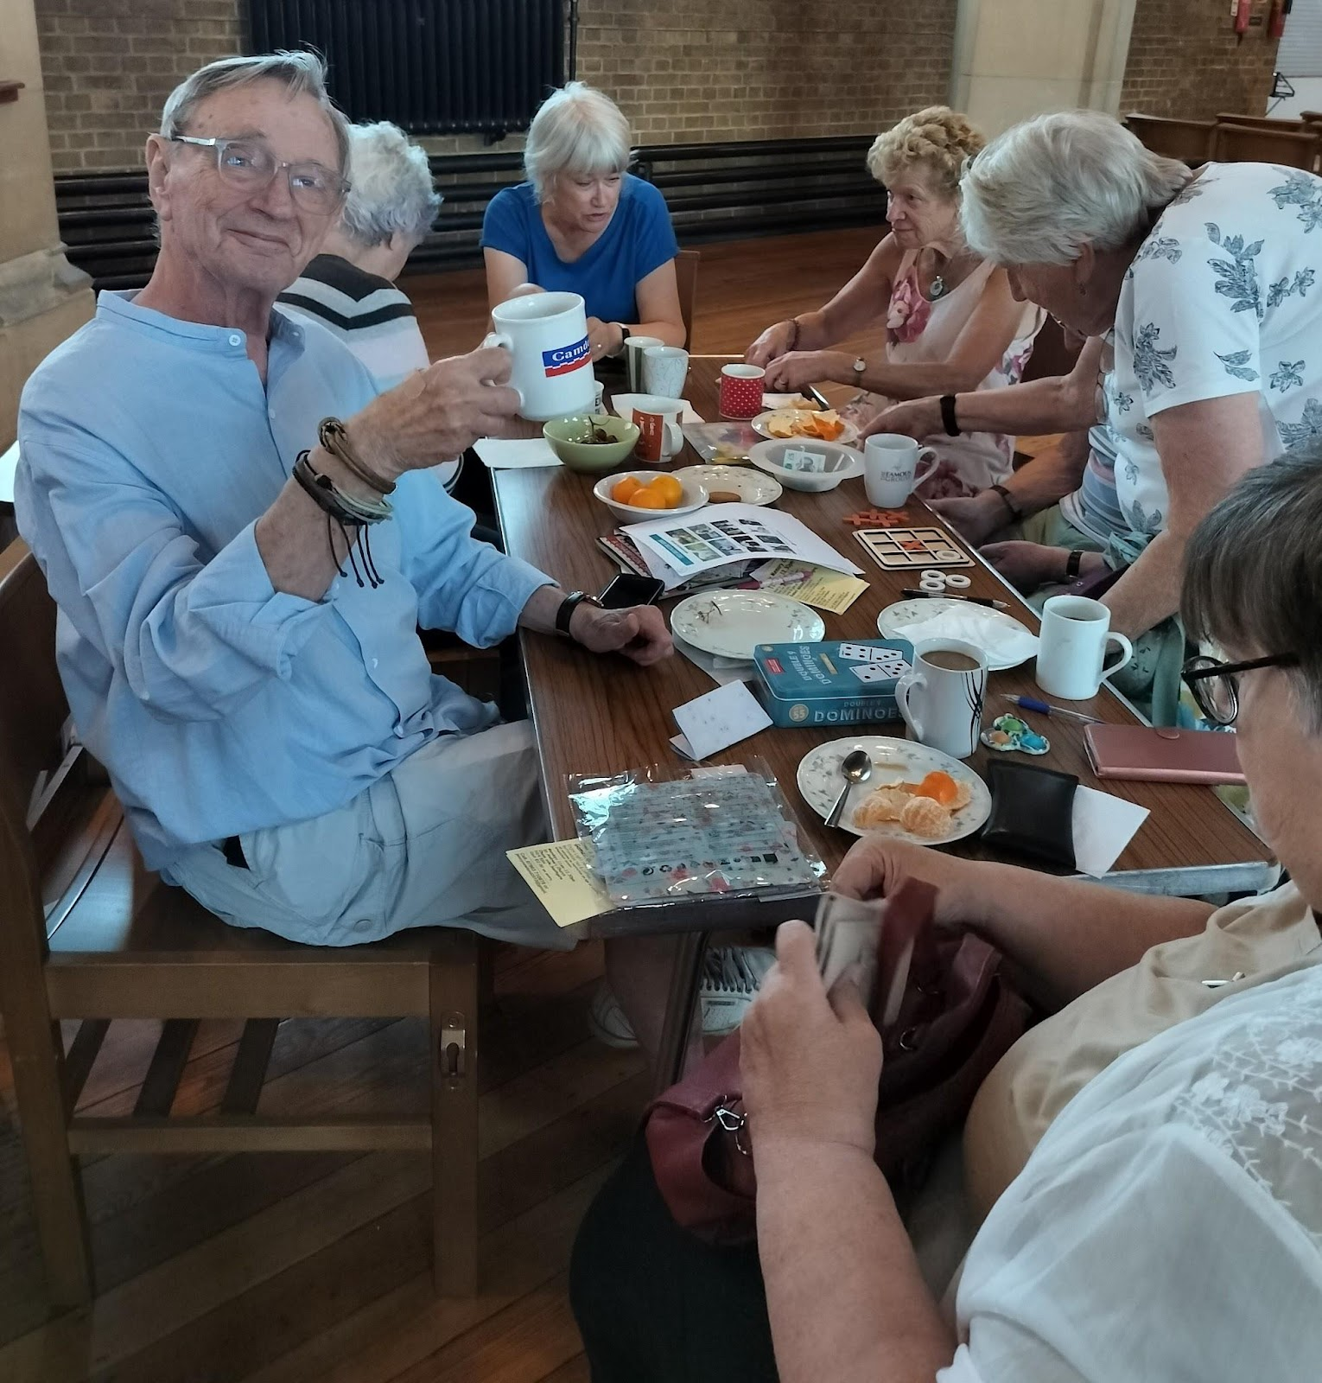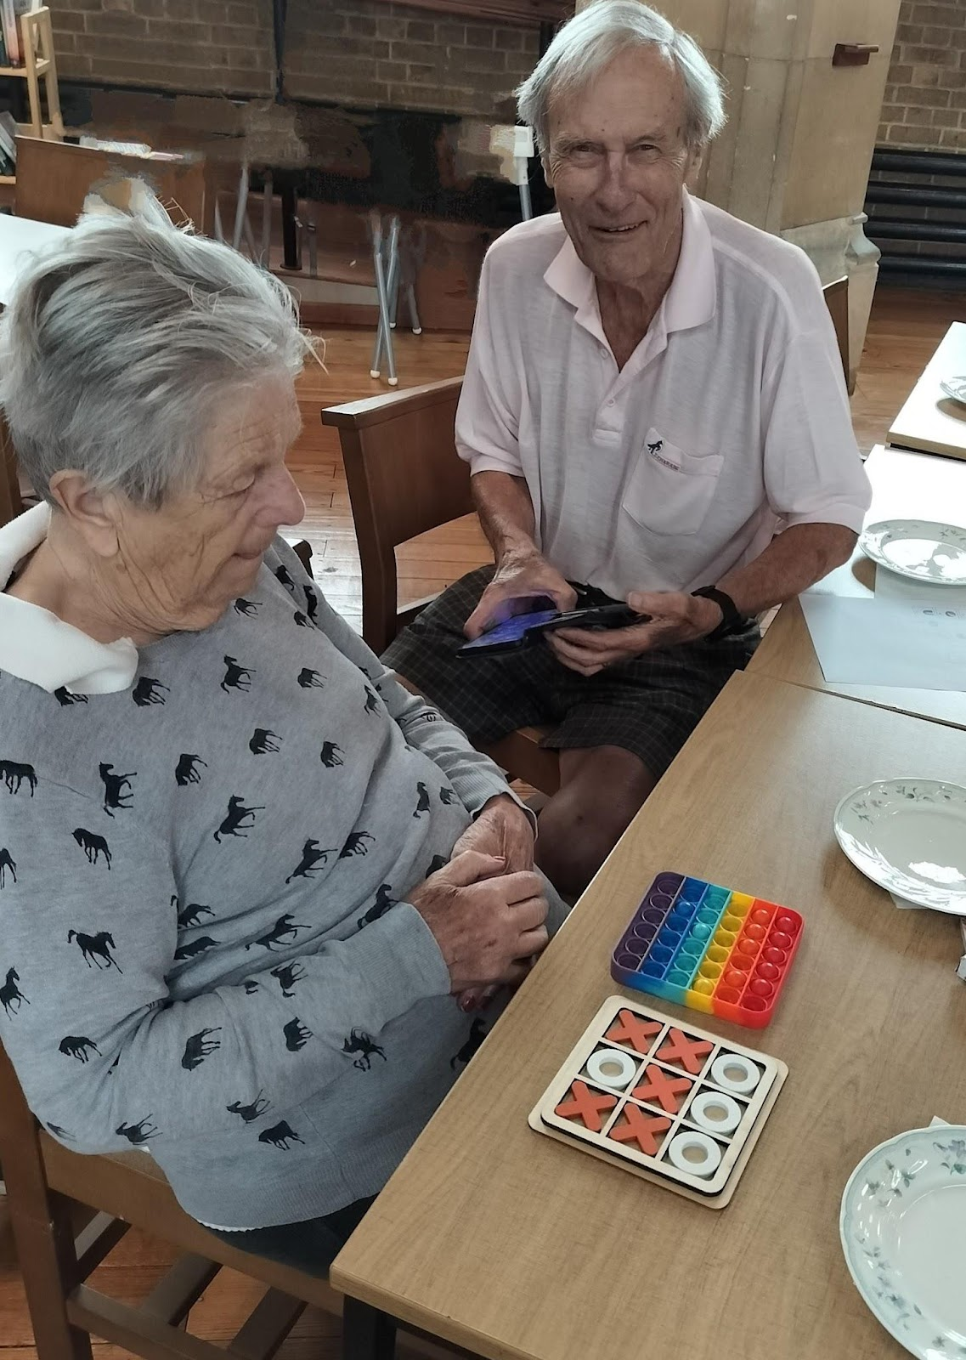
Want to chat, meet people &
have fun stimulating your brain?
Loved one, friend, carer or you?
Come and join us for
Games, quizzes, bingo, singing.
Enjoy light refreshments plus:
tea, coffee, herbal teas or hot chocolate.
All welcome, no restriction on age or ability.
------------------------------------------------------------------------------
St.Andrew’s Church (next to Asda)
Chase Side, Southgate, N14 5PP.
Cost £3.00 on entry.

*Nearest tube: Southgate station.
*121 & W6 buses stop at Southgate station.
*Buses 125,382,298,& 299 all go to Southgate tube & St.Andrew’s Church.

Call: 07903 710678 or email: mondaymemoryclub@gmail.com

SPONSORED BY:
*Community Champion Sejal Shah at Asda Southgate Circus.
*Enfield Dementia Network.
*Nominated for an Asda foundation communities grant.

